Blue Prism Process intelligence
  - Automation Supervisor – Installation & Configuration guide
Document Revision 1.1

Trademarks and copyright
The information contained in this document is the proprietary and confidential information of SS&C Blue Prism Limited and should not be disclosed to a third party without the written consent of an authorised SS&C Blue Prism representative. No part of this document may be reproduced or transmitted in any form or by any means, electronic or mechanical, including photocopying without the written permission of SS&C Blue Prism Limited.
© SS&C Blue Prism Limited, 2001 – 2023
®SS&C Blue Prism is a registered trademark of SS&C Blue Prism Limited
All trademarks are hereby acknowledged and are used to the benefit of their respective owners.
SS&C Blue Prism is not responsible for the content of external websites referenced by this document.
SS&C Blue Prism Limited, 2 Cinnamon Park, Crab Lane, Warrington, WA2 0XP, United Kingdom
Registered in England: Reg. No. 4260035. Tel: +44 870 879 3000. Web: www.blueprism.com

Contents
introduction 3
Data Pipelines 3
Working with virtual environments 6
Checking the installation 6
BPPI Token creation 7
The configuration file 9

Introduction
Automation supervisor is a solution which can be seen as a specific BPPI use case for COEs. As Many RPA COEs struggle to analyze and manage how their Blue Prism Digital Workers are actually performing, The purpose of Automation Supervisor is then to provide a simple application to show the value of the automation initiatives by providing clarity and data driven metrics.

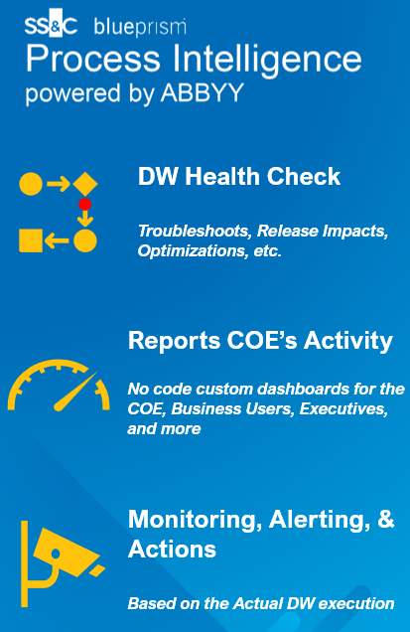 | Why using Automation Supervisor ?  - Difficult to detect all the bottlenecks in the BP developed processes  - It can be hard to define and provide concrete KPI and dashboards easily for management  - Presenting all the deviations and business/technical exceptions that happens in practice can be difficult  - It’s hard to be alerted and harder to be proactive when SLAs are missed or to ID other abhorrent behaviors  - It’s challenging to simulate and estimate the impact of changes (automations, and adding transformations, redesigns, & optimizations)

So as to propose such capabilities Automation Supervisor is composed by 2 parts:
- The Data Bridge: This bridge proposes a way to gather the data and push them to Blue Prism Process Intelligence (alias BPPI). It can read several data sources (like files, databases and Blue Prism), manages some transformation before loading them into BPPI
- BPPI (Blue Prism Process Intelligence)
This document is only focused on the Data Bridge.

How it works

introduction
This is the high level architecture of the solution. In the middle the solution acts as a bridge between the external data sources and Blue Prism Process Intelligence (BPPI):

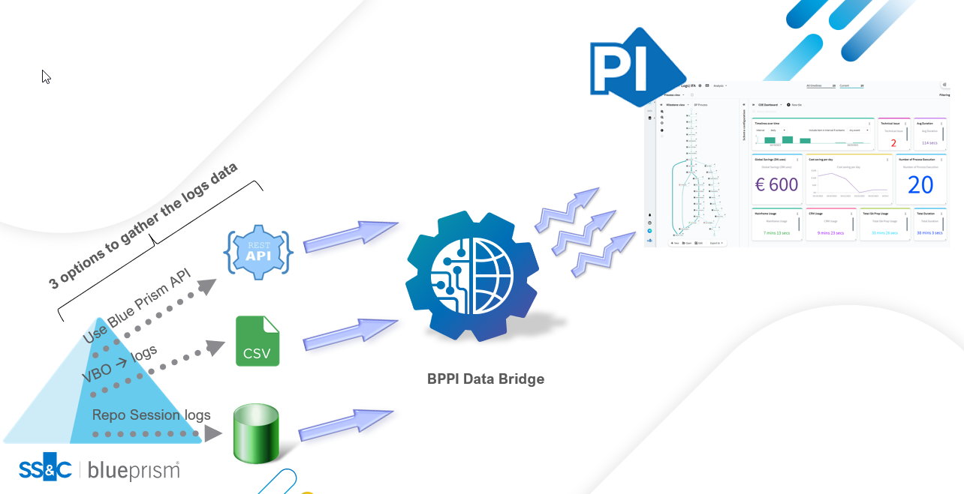

Note: The bridge is a gateway and does not store any data.

The Bridge manages the Data source and the BPPI connection and build a Data pipeline between the both of us. Of course in between the two connections, the bridges can also prepare the data and also make some data transformations depending of the needs and the configuration.
Currently the bridges loads the data by using the repository first. So after gathering the data source dataset all of those data are pushed into a table into the BPPI Repository. It's possible to add another step to load automatically load these data into a BPPI project by creating a To Do into BPPI. This To Do can be executed by just specifying an option in the bridge configuration.
This way (managing a intermediate step with the BPPI Repository) enables the BPPI administrator to create and add other data operations and also make himself the BPPI mapping (Timeline iD, Event Id and Timestamp).

Data Pipelines
The Data pipeline provided by the Data Bridge follows the ETL pattern, that means it first Extract (E) the data from the data source, make some Transformations (T) if needed and lastly Load (L) the result into the BPPI Repository.

These are the different steps when running the bridge:

- The first two steps are specifics to the Data source
- The Bridge gather the data from the data source and then manage to do some transformations (filtering, format change, etc.)
- The connection to BPPI is done via the Native API interfaces
- The data are loaded into a Repository table
- (Optional) A BPPI To Do is executed. For example to make some transformations and load the Repository table into a BPPI Project

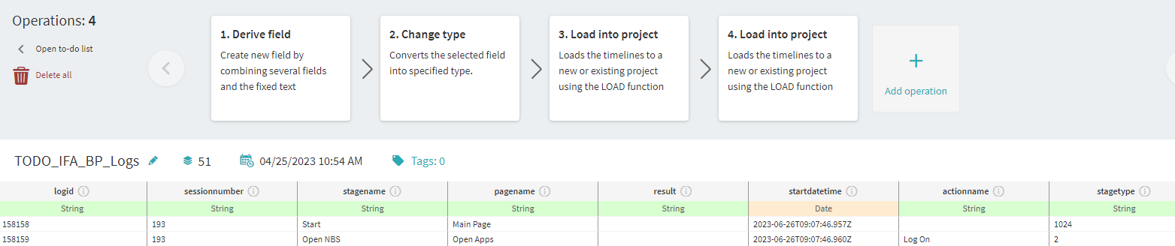

In the example below, the BPPI To Do execute different BPPI Data operations before loading the result into a BPPI Project:

Requirements
Python 3.10.x minimum is required to run the Bridge. You can download the release here https://www.python.org/downloads/release/python-3100 (or you can use a distribution line Anaconda).
Some Python are required Python library and will be installed automatically. They are listed below for information:
- pandas==2.0.3
- openpyxl==3.1.2
- pyodbc==4.0.39
- requests==2.31.0
- xmltodict==0.13.0
The Bridge uses the BPPI officials API so it's mandatory to configure correctly the BPPI repository first. See the BPPI Configuration chapter for more details.
For the ODBC Connectivity and Blue Prism Connectivity an ODBC Connection string and a User/password is necessary to query the data base. Only Read access privileges on the queried tables are needed.
For the Blue Prism Connectivity (via Direct repository access), the read only access is required for these Tables:
- BPASession
- BPAResource
- BPASessionLog_NonUnicode or BPASessionLog_Unicode
The configuration file (config.ini-template) is mandatory for all connectivity and must be filled out carefully before using the Bridge.
You should have in hands the package installation file which looks like PIDG-x.x.x-py3-none-any.whl

Installation
Before starting the installation you must check the all pre-requisites.

Working with virtual environments
Note: it’s highly recommended to create a Python virtual environment to avoid any problems with other Python Packages (conflicts).
Just run beforehand (windows):
$ python -m venv .venv_PIDG
Then activate the new environment:
$ cd .venv_PIDG/Scripts
$ activate
The prompt should be changed like this:
(.venv_PIDG) C:\Temp\.venv_PIDG\Scripts>

Package installation
If you have created a Python virtual environment, please activate it before installing the solution (Cf. the instructions above).
You should also have a whl file which contains all the necessary scripts for the deployments : PIDG-x.x.x-py3-none-any.whl
Open a command line and use the pip utility to install the solution:
$ pip install PIDG-x.x.x-py3-none-any.whl
- Warning: Run this pip install command line from the right Python environment (especially if you use a virtual one / see next section).
You should have several information written in the command line like this:
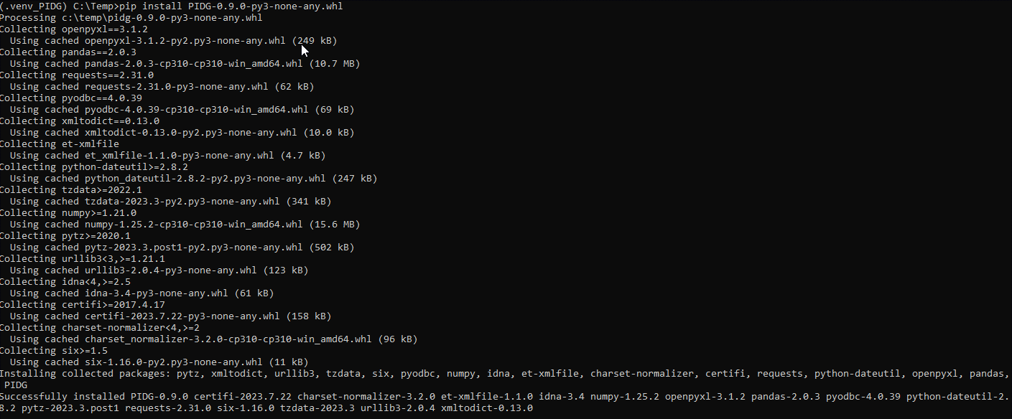
The last message with “Successfully installed PIDG-x.x.x” means your installation is successful.

Checking the installation
Just type in the command line:
$ pidg
The usage should be displayed like this :
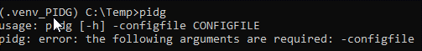

Configuration
The BPPI Data Bridge needs some mandatory and basics configuration to be functional.
- Some entries must be filled out in the configuration file
- The BPPI Connectivity for the APIs is mandatory (to get a access token)

BPPI Token creation
Before using this bridge it's mandatory to configure BPPI to enable such importation like this, in fact the goal here is to generate an access token. To do that you must have enough rights to create a DATA SOURCE into the BPPI Repository.
This configuration provides a token that will be necessary to use the BPPI API and then get access to the BPPI Repository.
These are the steps to follow in this order:
1) After logging to BPPI, click on the Repository button (on the left pane):

2) Into the BPPI repository navigate and select the DATA SOURCES (menu on the top):
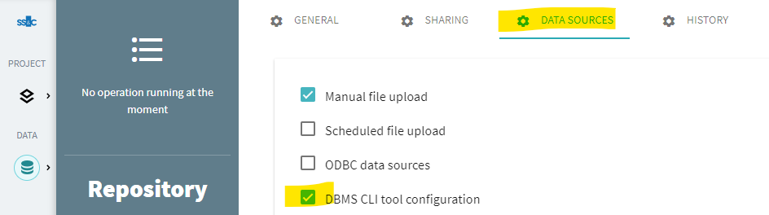
3) Then create a new Data Source by clicking on the [Add database configuration]. This button is at the bottom, below all the data sources already created:

4) A new form is displayed :

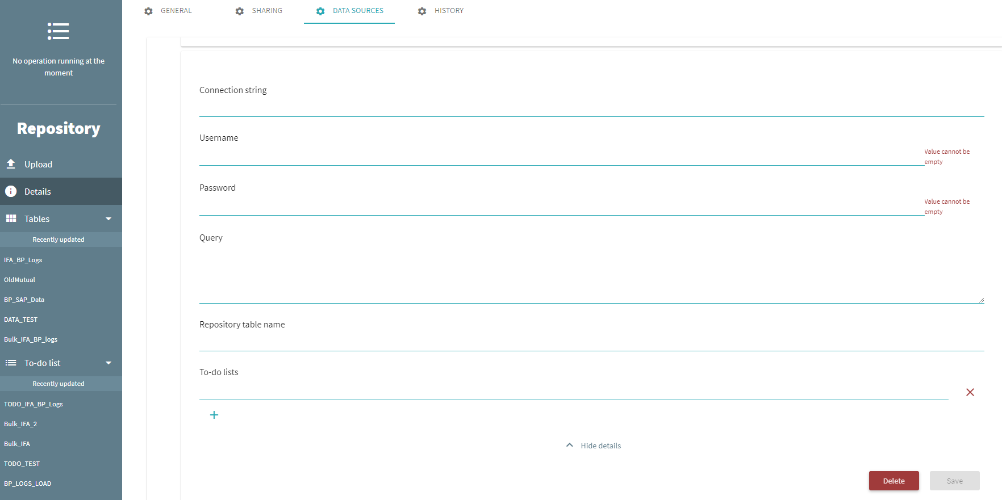
- Give a unique name (internal) of this Data Source connection
- All the information are not used. Some of them are mandatory fields (like username, password, etc.) but not used, so just put something in those fields like Dummy string. Don't worry about these configuration they will be filled out later (in the configuration file)
- Click on save

5) A token must have been created now, you can copy it for the bridge configuration later:

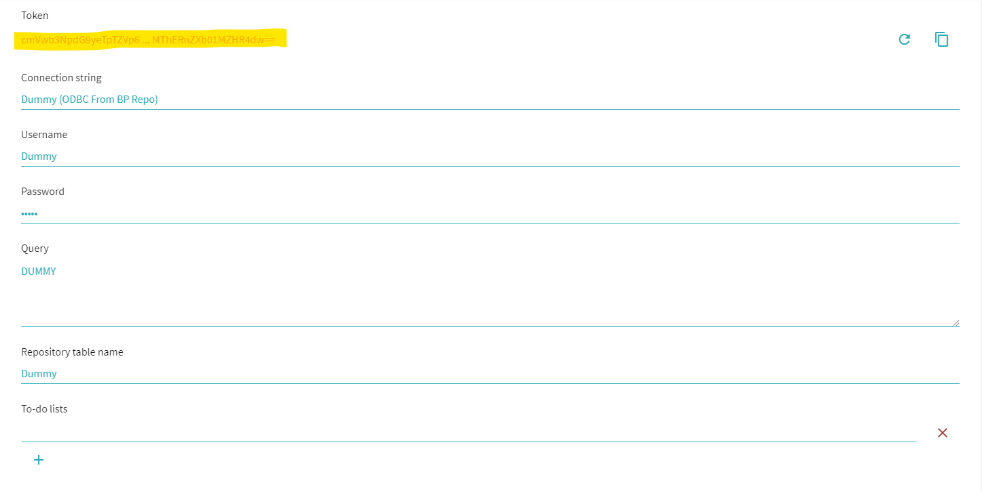

The configuration file
Before using the bridge it's mandatory to create a configuration file. This configuration files is a INI format file (with sections and entries) so it’s pretty easy to make it. This configuration file will be used in the command line when launching the script (here we use config.ini as configuration file):
Example:
$ pidg -configfile {config.ini}
There are several types of sections:
- The mandatory sections
- The optional sections
- The sections related to a specific Data Source (so please refer to the Data source documentation for the configuration)
Let’s review the different mandatory and optional sections first:

The mandatory sections

The [bppi] section
This section must look like, and manages the BPPI credentials and options :
Those entries must be specified in the **[bppi]** section:
- url Specifies the BPPI URL (Note, please don't put the last slash at the end of the url)
- token this token is delivered after configuring the BPPI Datasource (Cf. BPPI Configuration)
- table This contains the name of the Repository Table that is already created in the BPPI Repository (if it does exists yet, this table will be created at the first load).
- todos (yes/no) Launch the TO DO in BPPI
- todolist Contains a list of BPPI To do to execute after loading the data (the to do needs to be separated by a comma)
Example:
[bppi]
url=https://mybbpiserver.com
token=******
table=IFA_BP_Logs
todos=yes
todolist=TODO_IFA_BP_Logs

The [other] section
The log section is about how the Bridge will provides traces and logs while executing.
- logfolder Specifies the Log file location (with a slash at the end)
- logfilename Specifies the Log file name
- loglevel (DEBUG|INFO|WARNING|ERROR) Log trace level
- logformat Log Format (Python format), use a %% to escape the % sign (% is the only character that needs to be escaped) ([see the Python reference](https://docs.python.org/3/library/logging.html))
Example:
[other]
logfolder=C:\...\Demo\BP Logs\IFA (No Bulk)\
logfilename=bppi-bridge.log
loglevel=DEBUG
logformat=%%(asctime)s|%%(name)s|%%(levelname)s|%%(message)s

The optional sections

The Event mapping
The aim of this activity is to clean up the list of events (EVENT_ID). Most of the time those informations come from different data sources and can have different values for the same meaning, or there are just too much events and it may be necessary to filter out some of them (not necessary for the analysis). For these reasons and others, you may have to manage an Event mapping activity workshop.
At the end of this workshop you should have a simple list of events with:
- The old event name
- The new event name (if nothing is specified that just mean the event log must be removed)
Note: The resulting file must be a CSV file (with comma as separator).

Event management (filtering or renaming)
The Bridge enables to automatically make some changes in the event names and also filter out some of them by using their name according to the rule previously detailed. To make that possible you just have to provide the event map file (CSV) and also specify some options in the configuration file.
This is how the file must be constructed
- It's a CSV file
- Use the comma as separator
- The First columns contains the name of event ID (in the source data)
- The Second columns contains:
  - The new name (that will appear in BPPI) if there's something filled out. In this case the old (source) evend id is just replaced by this one.
  - if nothing, this event log (the entire row) is simply removed
Note: the Columns header names do not matter, however the solution assumes there are headers.
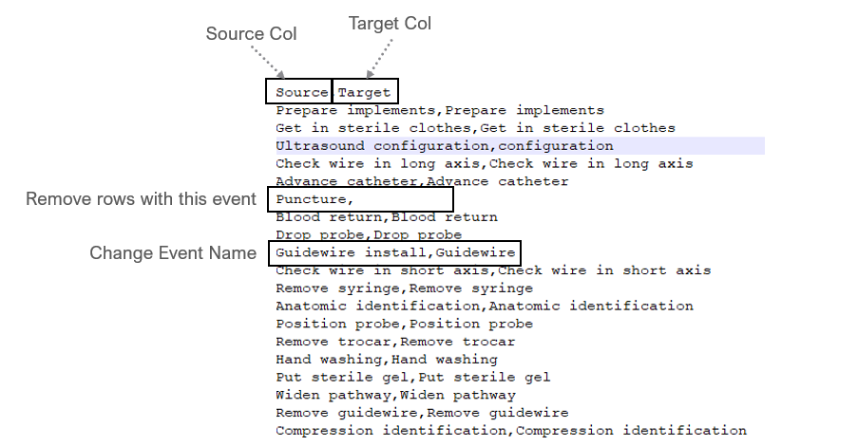
If the Source Column find a match in the Event Map file (Column 1)
If there is a data (not Null) in Event Map file (Column 2)
Then The Source Column is replaced by the Event Map file (Column 2)
Else
The Source Row is removed
Else
The Source Row is removed

Configuration
In the [events] section, you must specify then:
- map (yes|no) if you want this mapping/filtering to happen or not
- maptable filename with the above table
- eventcolumn column name to map from the data source

Example:
[events]
# Map the event names in the source dataset with a event map file (CSV file with two columns)
map=no
maptable=./test/evtmap.csv
eventcolumn={column to map in the data source}

Template creation
If in the configuration file map=yes but the file (parameter maptable) does not exist, then the solution will create:
- A template event file (CSV)
- Use the file name in the *parameter maptable*
- With all the distinct values of the event source file (same values in both columns).
It's then up to the user to reuse that file and update it accordingly to his needs.

Accessing Blue Prism logs via the Repository
The purpose of this chapter is to describe how the Data Bridge gathers the Blue Prism logs by directly connecting to the Blue Prism Repository.

Characteristics
These are some characteristics of this bridge:
- Gather logs from a selected Blue Prism process (use the processname parameter)
- Can collect the Blue Prism variable values (only the desired ones)
- Include or not the Objects/VBO logs (use the includevbo option). By including the VBOs activities it's possible to have a full view of the Process Execution.
- Support BP Unicode or BP Non-Unicode Logs (use the unicode option)
- Can gather Blue Prism logs data between 2 dates (use the command line todate and/or fromdate).
- Support Delta or Full load (use the delta option).
- Filter out/remove the selected stage types (For that, just use the stagetypefilters ini parameter an list all the stages types code not desired)
- Can exclude all the Start and End stages except the First & Last one in the BP parent process (the ones in the Main Page). By this way it removes Starts and Ends potential duplicates (which exists on each pages & VBOs)

Execute the bridge from command line
Only one parameter is needed :
- -configfile (Mandatory) Config file with all configuration details (INI format)
Example:
Launch the program via (windows or linux) command line like this:
$ pidg -configfile {config.ini}

Architecture
The solution can be installed anywhere and just need:
- To have access via ODBC to the Blue Prism Repository
- To have access to the BPPI server (via its own REST APIs)
- To have Python 3.10.* installed with the needed packages

Pre-Requisites:
The Bridge must access to some Blue Prism Repository tables:
- BPASession
- BPAResource
- BPASessionLog_NonUnicode or BPASessionLog_Unicode
the SQL Server credentials are obviously mandatory, but it's also important to ensure to have the read access privilege to those tables.

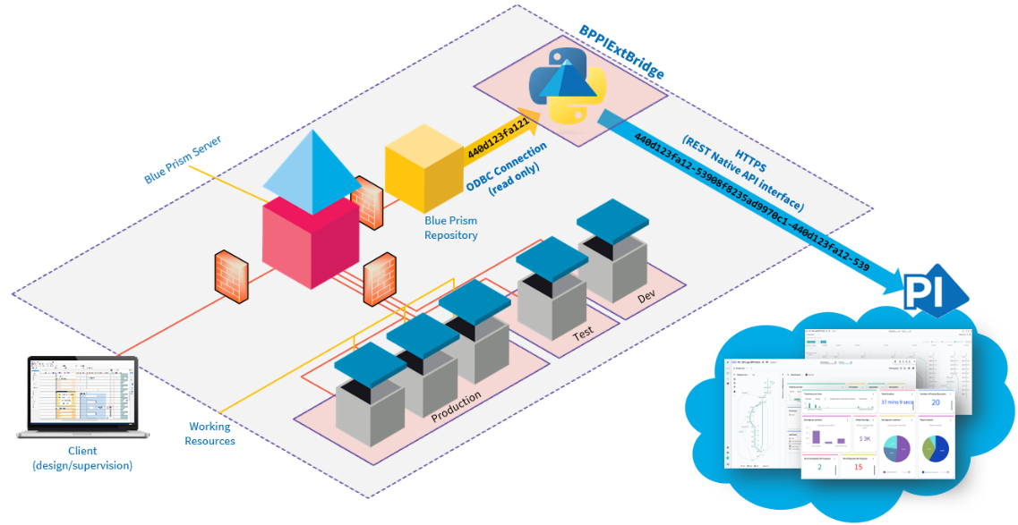

Configuration
The Bridge's configuration can be done in several steps.
Important Note: In Blue Prism it's possible to deactivate the trace (log) for each stage (Enabled, Disabled or on Error only), to be able to gather those logs after executing a Blue Prism Process it's mandatory to enable the logs for the stages you want to import into BPPI (Disabling the logs prevents Blue Prism to make some entries in the Blue Prism Reposotory).

The configuration file – Database - specific section
Before using the bridge it's mandatory to create a configuration file. This configuration files is at the INI format (with sections and entries).
The Blue Prism Repository Access is provided via a SQL Server ODBC Connection string.
Fill out the **[database]** section like this:
Only two entries are necessary:
- connections specifies the ODBC connection String.
ODBC Connection String example: DRIVER={ODBC Driver 18 for SQL Server};SERVER=localhost\SQLEXPRESS;DATABASE=;UID=;PWD=***;ENCRYPT=No
- query specifies the query template to use to query the Blue Prism Repository
Note: It's highly recommended to not change it except if you're really sure of what you're doing (at your own risk)
For information this is the SQL Query executed:
SELECT logId,
LOG.sessionnumber AS SessionID,
stageName,
result,
LOG.startdatetime AS resourceStartTime,
BPAResource.name AS ResourceName,
actionname,
stageType,
pagename,
attributexml,
IIF(processname IS NULL, 'VBO', 'PROC') as OBJECT_TYPE,
IIF(processname IS NULL, objectname, processname) as OBJECT_NAME
FROM $tablelog AS LOG, BPASession, BPAResource
WHERE LOG.sessionnumber IN
(SELECT distinct sessionnumber
FROM $tablelog
WHERE processname = '$processname'
AND $delta)
AND LOG.sessionnumber = BPASession.sessionnumber
AND BPAResource.resourceid = BPASession.runningresourceid
AND stagetype NOT IN($stagetypefilters)
AND $onlybpprocess

Example:
[database]
connectionstring=DRIVER={ODBC Driver 18 for SQL Server};SERVER={server Name}\{DB Instance};DATABASE={DB Name};UID={Username};PWD={Password};ENCRYPT=No
# filename which contains the SQL query
query=bplogs.sql

The configuration file – blueprism - specific section
It's possible to configure the way the bridge will gather and manage the Blue Prism logs just by managing theses entries into the [blueprism] section:
- processname Specifies the Process Name (only one Process can be investigated currently)
- parameters Here you can put the name of the parameters to gather from the BP log files (into the xmlattributes field). These parameters are in fact the variables which are managed by Blue Prism while executing the Blue Prism Process. Just put a list of those variables separated by a comma.
- stagetypefilters Your can list here (separated by a comma) all the stages types (by using their code) you want to filter out.
Some example here :
- 1 (always remove this one)
- 2 -> Action
- 4, 65536 -> Decision
- 8 -> Calculation
- 536870912 -> Multi Calculation
- 128 -> Call page
- 1024, 262144 -> Start
- 2048 -> End
- 131072 -> Writer
- 262144 -> Navigate
- 4194304 -> Wait
- 16777216 -> Alert
- 33554432 -> Exception

- includevbo (yes/no) Include or not (yes/no) the VBO logs. If no only the Blue Process logs are collected.
- unicode Indicates if we query the Unicode log table or not.
- startendfilter (yes/no) Only keep the Start and End stages in the main Process page (remove all the other Start & End stages in the VBOs and other pages)
- mainprocesspage if startendfilter=yes, this contains the name of the main Process page (by default Main Page)
- delta (yes/no) delta load activated, if no -> full load
- deltafile file where the latest timestamp load is saved (for the delta load only)

Example:
[blueprism]
processname=IFA Application Process
parameters=Customer Number,Product,Investment,Deposit,Reason Text
stagetypefilters=1,4,65536,8,536870912
includevbo=yes
unicode=no
startendfilter=yes
mainprocesspage=Main Page
delta=yes
deltafile=delta.tag

The solutions also enables to make some changes in the stages names and also filter out some of them by using their name. To make that possible it's possible to provide a table (in a csv file) with only two columns. When using Blue Prism as a source by default the first column is a combination of several fields which provides the unique identifier of a stage name (see below). This identifier is used to match with the first column.

- First columns contains the name of the real stage name. The format must respect this norm : {VBO|PROC}/{Process or Object Name}/{Process Page or VBO Action}/{Stage name}
  - {VBO|PROC} means the stage comes from a VBO or a Blue Prism Process
  - {Process or Object Name} Process or Object name
  - {Process Page or VBO Action}: Process Page (tab) or Object/VBO Action
  - {Stage name} Stage Name
- Second columns contains:
  - The new name (that will appear in BPPI) if there's something filled out
  - if nothing, this stage name is simply removed

in the [events] section, you must specify then:
- map (yes|no) if you want this mapping/filtering to happen or not
- maptable filename with the above table

Example:
[events]
# Map the event names in the source dataset with a event map file (CSV file with two columns)
map=no
maptable=./test/evtmap.csv

Accessing Blue Prism logs via the APIs
The purpose of this page is to describe how to Gather the Blue Prism logs by using the Blue Prism APIs. Of course the Blue Prism API must be deployed and you also need to get some API informations (ID, secret, etc.).

Characteristics
These are some characteristics of this bridge:
- Gather logs from a selected Blue Prism process (use the processname parameter)
- can collect the high level log data (not the variables)
- Include all then logs (from thr Process and the VBOs)

Execute (from Command line)
- -configfile (Mandatory) Config file with all configuration details (INI format)
Example:
Launch the program in the shell (windows or linux) command line like this:
$ pidg -configfile {config.ini}

Pre-Requisites
This bridges leverages the Blue Prism API. It works only from the version 7.x and thoes API must be installed and configured properly. An ID and Secret (from the Blue Prism Hub) must also be provided to get access to them.
Moreover, 2 URLs are necessary:
- The Authentication server URL (the one which checks the access and provide a security token)
- The API URL

The configuration file (ini)
Before using the bridge it's mandatory to create a configuration file. This configuration files is at the INI format (with sections and entries).
Several entries are necessary:

Section [blueprism]
- processname must contains the Blue Prism Process name
Example:
[blueprism]
processname=Load Customers Queue

Section blueprismapi
- ssl_verification if yes each API call checks the SSL Certificate
- client_id Blue Prism Hub client ID
- client_secret Blue Prism Hub client Secret
- auth_url Blue Prism Authentication server URL (without the slash at the end)
- api_url Blue Prism API URL (without the slash at the end)
- api_page_size Blue Prism API Page size (for returnning list of results)

Example:
ssl_verification=no
client_id = bpapi
client_secret = ***
auth_url = https://authentication.local
api_url=https://bpapi.local
api_page_size=300

